DHCP

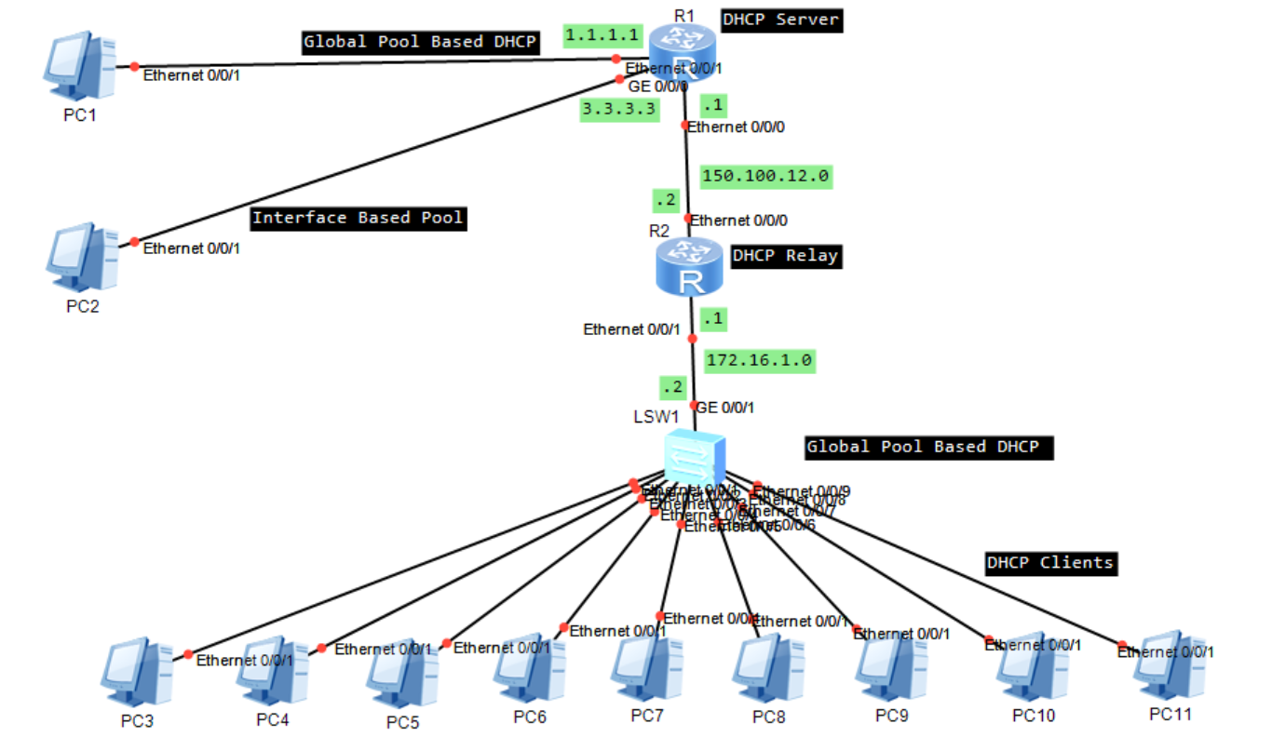

**Router 1 Configuration:**

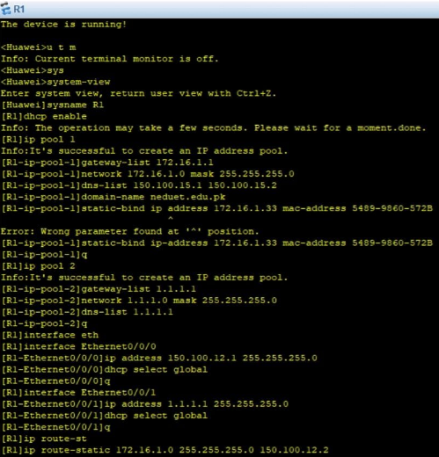

This screenshot captures the output of the display dhcp server ip-in-use command. It lists the IP addresses currently leased by the DHCP server along with corresponding MAC addresses and lease durations. This confirms successful DHCP operation and helps monitor active clients in the network.

**Router 2 Configuration:**

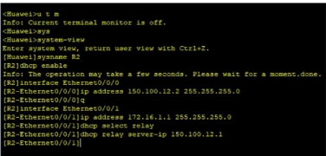

This screenshot captures the output of the display dhcp server ip-in-use command. It lists the IP addresses currently leased by the DHCP server along with corresponding MAC addresses and lease durations. This confirms successful DHCP operation and helps monitor active clients in the network.